SOFTWARE ENGINEERING LAB 7

LAB 7 – Fuzz Testing Report
Bowling Alley Input Validation

Name | Ahana Srinivas Sivaram
SRN | PES1UG24CS910
Section | H
Assigned project | Bowling Alley | Repository 64

Objective
Use Hypothesis property-based fuzz testing to expose failures caused by unexpected input in the bowling alley name, frame, and scoreboard functions, then harden the functions and rerun the tests.

Tested functions
format_player_name, parse_frame, and parse_scoreboard

Result
The buggy implementation failed the three fuzz properties while the valid-example checks passed. After defensive input handling was added, the test suite passed all four tests. The corrected SS4 terminal screenshot is reserved below and will be inserted when supplied.
Assigned repository: https://github.com/AhanaSrinivas/L6_L7_64_bowling_alley

SS1 Buggy application output
The application accepts representative valid inputs before fuzz testing.
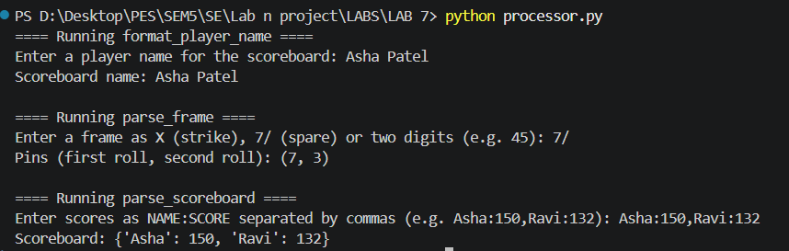
Figure 1. Starter application output using Asha Patel, 7/, and Asha:150,Ravi:132.

SS2 Hypothesis failures on the buggy implementation
Hypothesis minimized invalid inputs and exposed crashes in each of the three functions. The terminal summary reports three failed tests and one passing valid-example test.
Figure 2. Failure summary from the buggy implementation.

SS3 Fixed application output
The same representative valid inputs continue to produce the expected output after input validation was added.
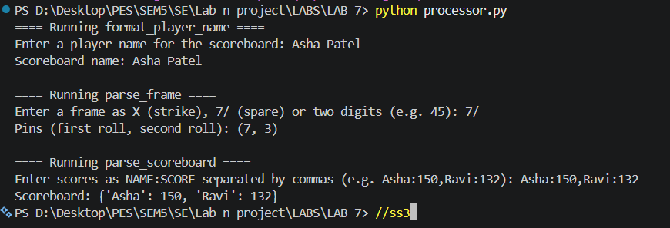
Figure 3. Fixed application output using the same valid inputs as SS1.

SS4 Passing Hypothesis tests
python -m pytest -q test_processor.py
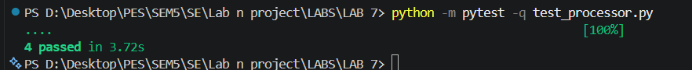

Additional SS2 failure details
The following screenshots continue the terminal traceback for SS2 and are included as supplementary evidence.

SS2 failure details 1 of 4
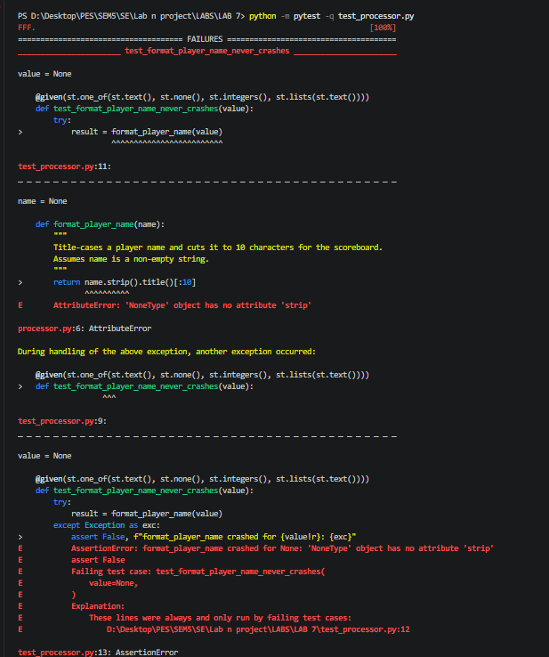

SS2 failure details 2 of 4
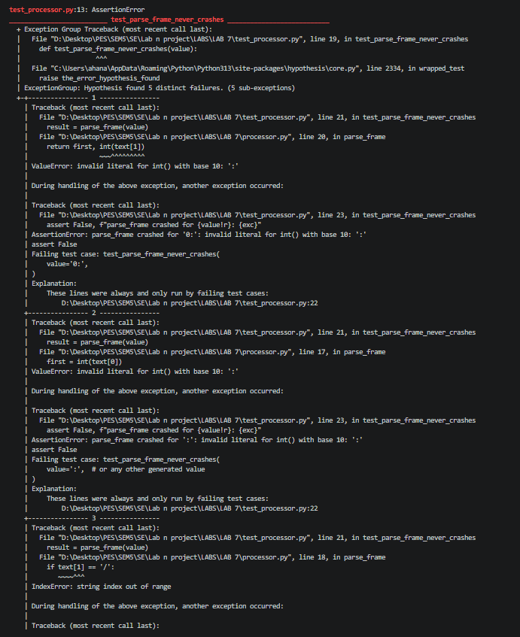

SS2 failure details 3 of 4
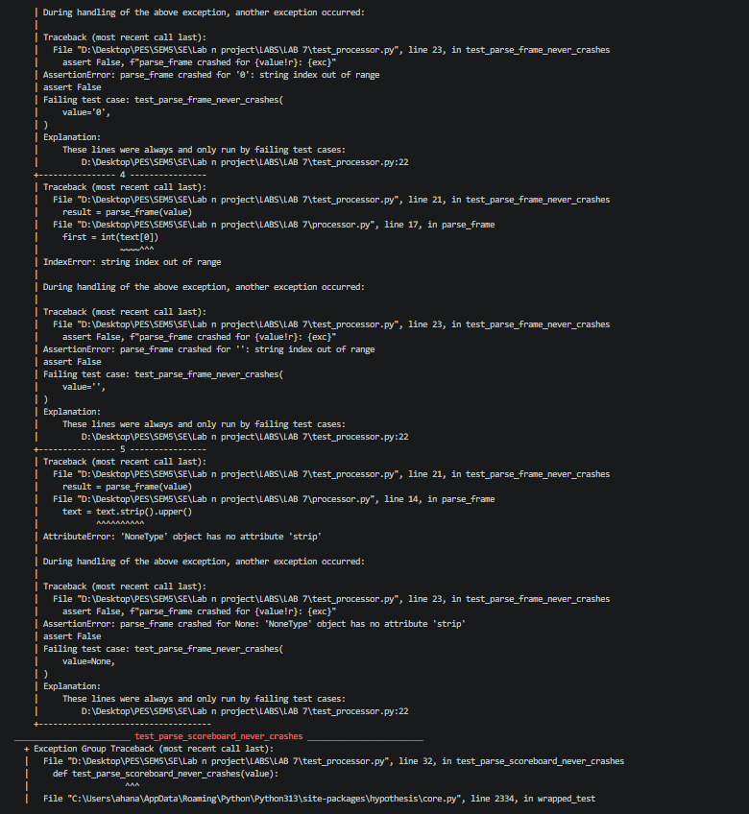

SS2 failure details 4 of 4


